April 11, 2012

Alva Electric Inc.
Attn: Andy Ricketts
118 W. Franklin Street
Evansville, IN 47710

Re MT Vernon Phase II Long Term Control Plan (WWTP)
Inspection No. 315677195

Dear Mr. Ricketts:

The Indiana Occupational Safety and Health Administration (IOSHA) conducted a comprehensive permit safety inspection of the facility listed above. This inspection resulted in no violations being noted and no safety order was issued. IOSHA appreciates your efforts in the area of safety and health.

Please feel free to contact the undersigned if you have any questions on our procedures.

Sincerely,

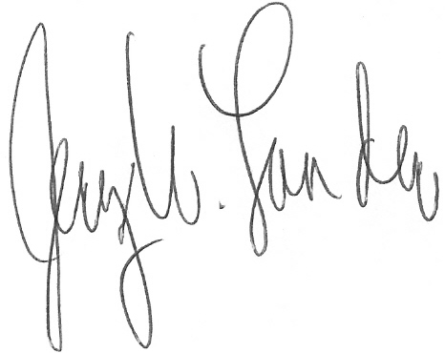
Jerry W. Lander, Director
Construction Safety Compliance

JWL :jlt
cc: file

